CROATIAN LANGUAGE COURSE IN DUBROVNIK  July 17 – August 11, 2017  Centre for Mediterranean Studies in Dubrovnik  CAAS, Don Frana Bulica 4, 20000 Dubrovnik, Croatia  Our courses are following the guidelines of the Common European Framework of Reference for Languages and are structured in 6 levels. The lessons offer a variety of conversation practice, discussions, listening and reading texts as well as grammar exercises under the guidance of our highly qualified and experienced teachers. | 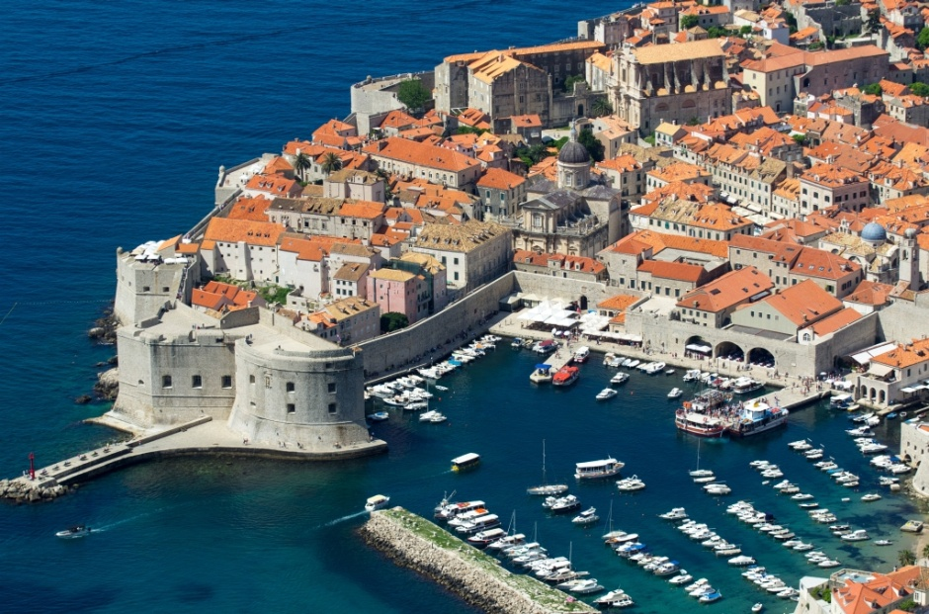
TYPE OF COURSE TERMS COURSE FEE  Regular course 20 teaching hours per week (900min) (4 teaching hours per day, Monday to Friday) TWO-WEEK COURSES: A July 17 –28, 2017 *B. July 31 – Aug 11, 2017 *this term is not for beginners 600,00 Euro  THREE-WEEK COURSE: July 17 - Aug 4, 2017 850,00 Euro  FOUR-WEEK COURSE: July 17 – Aug 11, 2017 1.100,00 Euro  Teaching hour = 45 minutes  Every individual tutorial (extra teaching hour) costs 55,00 Euro  Except regular courses there is a possibility to take one week course. | 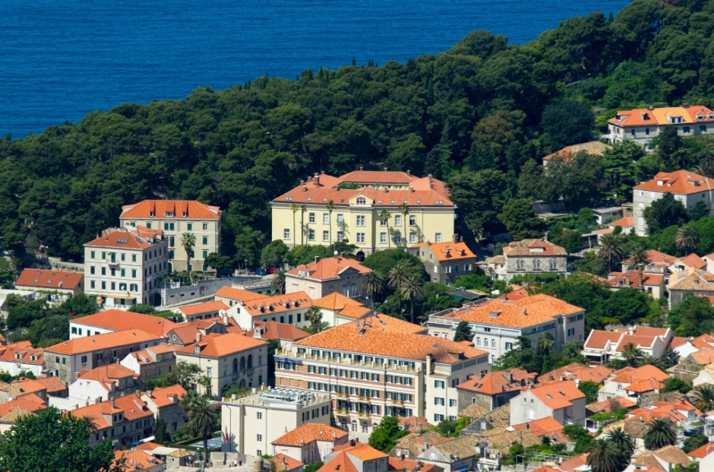
COURSE FEE INCLUDES:  - Teaching materials (student’s book, workbook, CD)  - Guided city tour  - Excursion to Dubrovnik surrounding  OPTIONAL (not included in the course fee):  - Optional trips or second excursion to Dubrovnik surrounding  - Tickets to museums and Dubrovnik summer festival performances/concerts  - Costs of accommodation  Accommodation in the same building where the lectures will take place  CAAS Apartments – 2nd floor Please contact: Ms Tanja Grzilo Phone: 00385 (0)20 326 381 Fax: 00385 (0)20 326 390 E-mail: tanja.grzilo@caas.unizg.hr 7 Double-beds apartments with kitchenette and bathroom a) single use price per day b) double use price per person per day (only if there will be another participant willing to share the apartment with you) 40,00 Euro 20,00 Euro  CAAS Residence – 3rd floor Please contact: Ms Tanja Grzilo 7 Single rooms with bathroom 31,00 Euro |  | 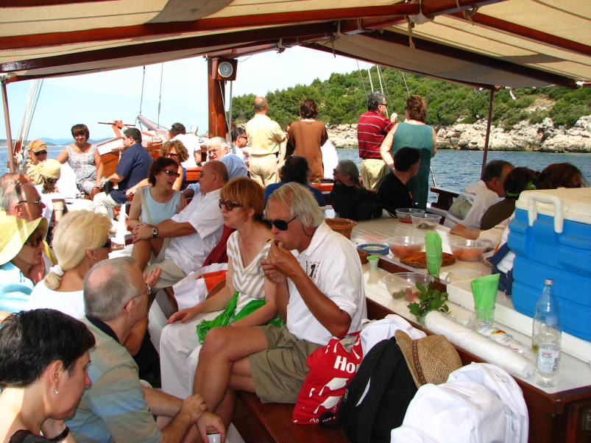  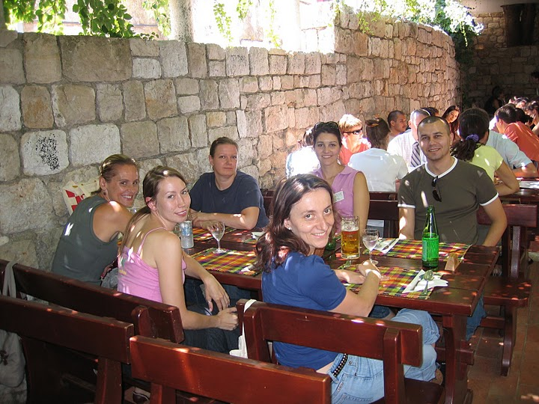

IMPORTANT INFORMATION

1. You may apply for one of the courses if you are 16 and over
2. Please send your application to the following E-mail address: tanja.grzilo@caas.unizg.hr
3. For any further information you may need, please contact us:
Phone: 00385 (0)20 326 300 Fax: 00385 (0)20 326 390
Contact: Ms Tanja Grzilo
E-mail: tanja.grzilo@caas.unizg.hr, cms.dubrovnik@gmail.com
4. Upon receipt of your application we shall send you:
- Confirmation of your enrolment
- Payment info

5. Each course participant will get a CERTIFICATE of course attendance
6. Accommodation in the city - Boarding School /Contact: Nun Meri Muse, merimuse@gmail.com
7. Private accommodation: Our Centre is situated on Pile. When looking for a private accommodation we suggest you indicate the
location and ask for the place somewhere in the neighbourhood (Pile, Old City or Ploce).

AGENDA 2017
1ST WEEK

Monday 17/7 | Tuesday 18/7 | Wednesday 19/7 | Thursday 20/7 | Friday 21/7 | Saturday 22/7 | Sunday 23/7
Morning or Afternoon Classes | Morning or Afternoon Classes | Morning or Afternoon Classes | Morning or Afternoon Classes | Morning or Afternoon Classes | 1st Excursion to Dubrovnik surrounding – By boat: Elafity Islands
 | 17.00 – 19.00 Guided city tour*
2ND WEEK

Monday 24/7 | Tuesday 25/7 | Wednesday 26/7 | Thursday 27/7 | Friday 28/7 | Saturday 29/7 | Sunday 30/7
Morning or Afternoon Classes | Morning or Afternoon Classes | Morning or Afternoon Classes | Morning or Afternoon Classes | Morning or Afternoon Classes
 |  |  | 17.00 – 18.30 Croatian Movie *
3RD WEEK

Monday 31/7 | Tuesday 1/8 | Wednesday 2/8 | Thursday 3/8 | Friday 4/8 | Saturday 5/8 | Sunday 6/8
Morning or Afternoon Classes | Morning or Afternoon Classes | Morning or Afternoon Classes | Morning or Afternoon Classes | Morning or Afternoon Classes | 2nd Excursion to Dubrovnik surrounding
 | 17.00 – 19.00 Guided city tour* |  |  | 17.00 – 18.30 Croatian Movie*
4TH WEEK

Monday 7/8 | Tuesday 8/8 | Wednesday 9/8 | Thursday 10/8 | Friday 11/8
Morning or Afternoon Classes | Morning or Afternoon Classes | Morning or Afternoon Classes | Morning or Afternoon Classes | Morning or Afternoon Classes
 |  |  |  | END of the course
* The exact day and the time will be agreed with the teachers during the course; this is proposed term.
Those who would like to have individual tutorials (extra teaching hours) will arrange the schedule and contents with teachers upon arrival.

WEEKLY TIMETABLE

Morning Classes | Monday | Tuesday | Wednesday | Thursday | Friday
Lesson 1 | 09.00 - 09.45 | 09.00 - 09.45 | 09.00 - 09.45 | 09.00 - 09.45 | 09.00 - 09.45
Lesson 2 | 09.45 - 10.30 | 09.45 - 10.30 | 09.45 - 10.30 | 09.45 - 10.30 | 09.45 - 10.30
Morning Break | 10.30 - 11.00 | 10.30 - 11.00 | 10.30 - 11.00 | 10.30 - 11.00 | 10.30 - 11.00
Lesson 3 | 11.00 - 11.45 | 11.00 - 11.45 | 11.00 - 11.45 | 11.00 - 11.45 | 11.00 - 11.45
Lesson 4 | 11.45 - 12.30 | 11.45 - 12.30 | 11.45 - 12.30 | 11.45 - 12.30 | 11.45 - 12.30
Afternoon Classes | Monday | Tuesday | Wednesday | Thursday | Friday
Lesson 1 | 13.00 – 13.45 | 13.00 – 13.45 | 13.00 – 13.45 | 13.00 – 13.45 | 13.00 – 13.45
Lesson 2 | 13.45 – 14.30 | 13.45 – 14.30 | 13.45 – 14.30 | 13.45 – 14.30 | 13.45 – 14.30
Afternoon Break | 14.30 – 15.00 | 14.30 – 15.00 | 14.30 – 15.00 | 14.30 – 15.00 | 14.30 – 15.00
Lesson 3 | 15.00 – 15.45 | 15.00 – 15.45 | 15.00 – 15.45 | 15.00 – 15.45 | 15.00 – 15.45
Lesson 4 | 15.45 – 16.30 | 15.45 – 16.30 | 15.45 – 16.30 | 15.45 – 16.30 | 15.45 – 16.30
Usually the beginner group starts with morning classes while the advance group starts with afternoon classes first week.

Those who would like to have individual tutorials (extra teaching hours) will arrange the schedule and contents with teachers upon arrival.

LITERATURE:  Marica Čilaš-Mikulić, Milvia Gulešić Machata, Dinka Pasini, Sanda Lucija Udier  HRVATSKI ZA POČETNIKE 1 – Student book and dictionary  HRVATSKI ZA POČETNIKE 1 – Student Workbook  HRVATSKI ZA POČETNIKE 1 – CD  Marica Čilaš-Mikulić, Milvia Gulešić Machata, Sanda Lucija Udier  RAZGOVARAJTE S NAMA A2B1 – Student book and dictionary  RAZGOVARAJTE S NAMA – Student Workbook  RAZGOVARAJTE S NAMA - CD  Marica Čilaš-Mikulić, Milvia Gulešić Machata, Sanda Lucija Udier  RAZGOVARAJTE S NAMA B1B2 – Student book and dictionary  RAZGOVARAJTE S NAMA – Student Workbook  RAZGOVARAJTE S NAMA - CD | Vesna Kosovac, Vida Lukić  UČIMO HRVATSKI 1 – Student book and workbook  UČIMO HRVATSKI 1 - CD  UČIMO HRVATSKI 2 – Student book and workbook  UČIMO HRVATSKI 2 - CD  (Centar za strane jezike Vodnikova i Školska knjiga)  Višnja Kostrenčić, Miljenko Kovačićek, Vida Lukić  UČIMO HRVATSKI 3 – Student book and workbook  UČIMO HRVATSKI 3 - CD  UČIMO HRVATSKI 4 – Student book and workbook  UČIMO HRVATSKI 4 - CD  (Centar za strane jezike Vodnikova)  Materials adapted to the needs of participants (individual lessons, exercises for translators)
Beside the schoolbook, teachers bring in and use extra, up-to-date materials such as excerpts from various texts, newspaper or magazine clippings.
In order to immerse our students in our culture, increase their educational experience and make their staying more pleasant, every year we offer some extracurricular activities such as Croatian movies showing, guided city tour and excursion to Dubrovnik surrounding. We also provide them unique opportunity to attend some of the concerts, folklore and theatre performances during the Dubrovnik Summer Festival free of charge.

